#### SRI KRISHNA COLLEGE OF TECHNOLOGY

**An Autonomous Institution | Accredited by NAAC with 'A' Grade Affiliated to Anna University | Approved by AICTE**

#### KOVAIPUDUR, COIMBATORE 641042

**EVENT CRAFT PRO**

**A Party Event Management App**

#### A PROJECT REPORT

***Submitted by***

**BALAJI.V 727821TUIT015**

**INDHU.K.S 727821TUIT039**

**INIKA.V 727821TUIT041**

***in partial fulfillment for the award of the degree of***

#### BACHELOR OF TECHNOLOGY

#### IN

**DEPARTMENT OF INFORMATION TECHNOLOGY**

#### April 2024

**Event Craft Pro : A Party Event Management App**

**Introduction:**

Event Craft Pro is your ultimate party event management solution, meticulously crafted to elevate every celebration to extraordinary heights. Whether it's a birthday bash, corporate event, or wedding extravaganza, we specialize in orchestrating unforgettable experiences tailored to your unique vision. Our intuitive platform seamlessly connects clients with top-tier vendors, ensuring seamless coordination and flawless execution every step of the way. From venue selection to entertainment, catering, and decor, our dedicated team handles all the intricate details, allowing you to relax and revel in the magic of your special occasion. Experience the pinnacle of event planning with Event Craft Pro – where every moment is crafted with precision and passion.

**Objective:**

Event Craft Pro aims to revolutionize party event management by providing a comprehensive platform that simplifies the entire process from planning to execution. Our objective is to empower users with the tools and resources needed to seamlessly organize and host unforgettable events. Whether it's a small gathering or a large-scale celebration, our app offers intuitive features for venue selection, vendor coordination, budget management, guest list organization, and more. By streamlining these tasks, we aim to save users valuable time and effort while ensuring that every detail of their event is meticulously planned and executed to perfection. With Event Craft Pro, creating memorable experiences has never been easier.

**User Flow Chart:**

Login Page

Billing Page

Booking Page

Register Page

**isRegister?**

**isLoggedIn?**

Clicking on **“Book Now”**

Home Page

Events Page

**User Modules:**

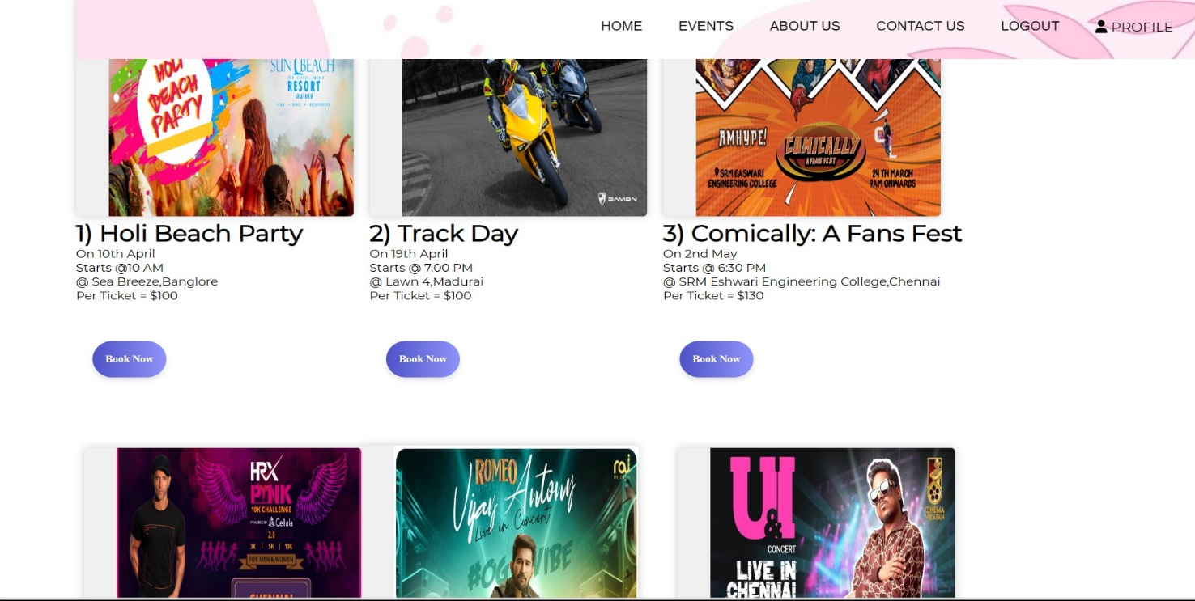 **Home Page**

**Events Page**

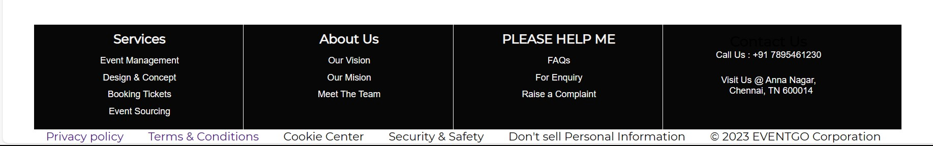

**Footer**

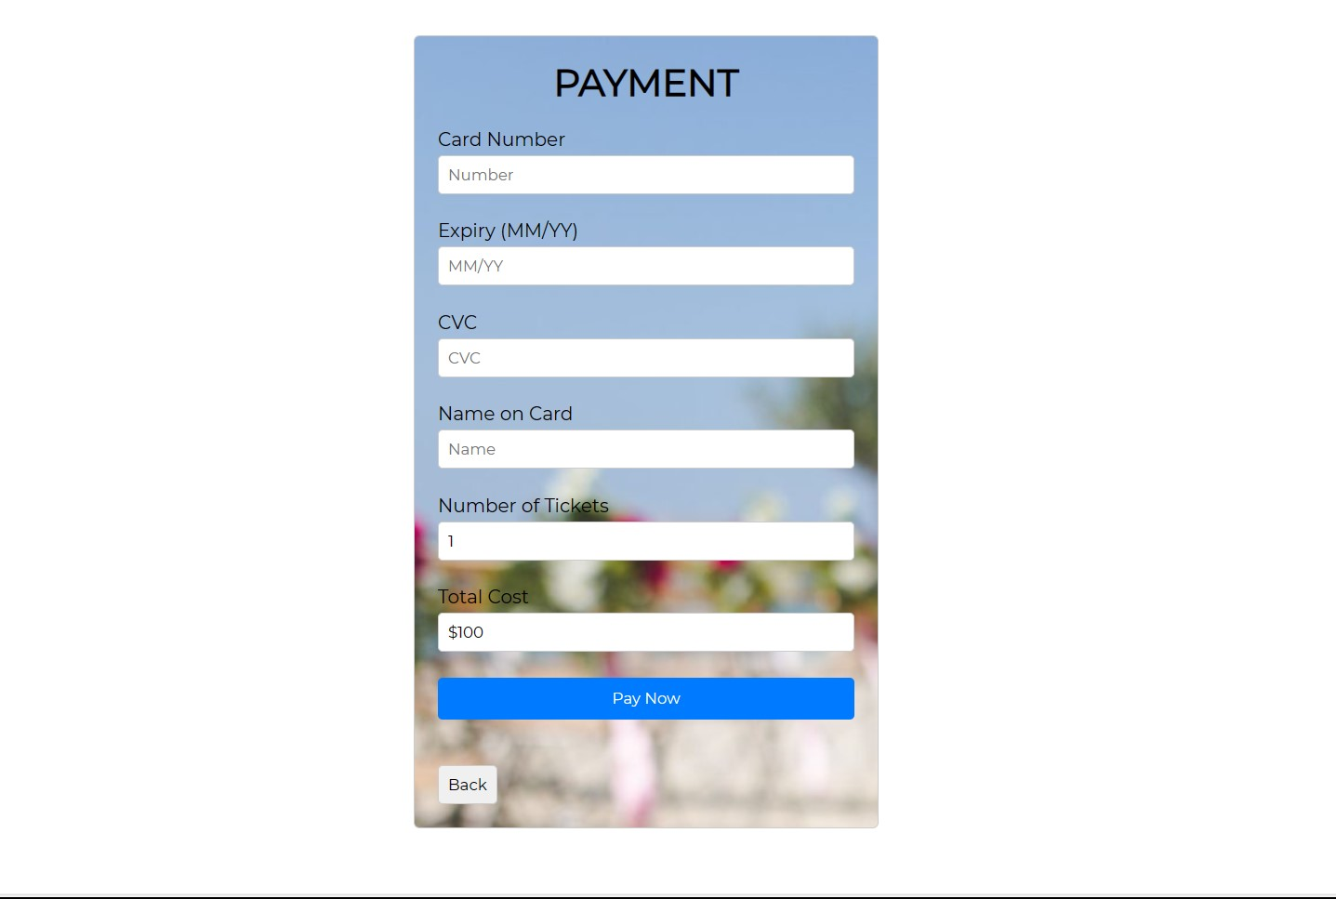

**Payment Page**

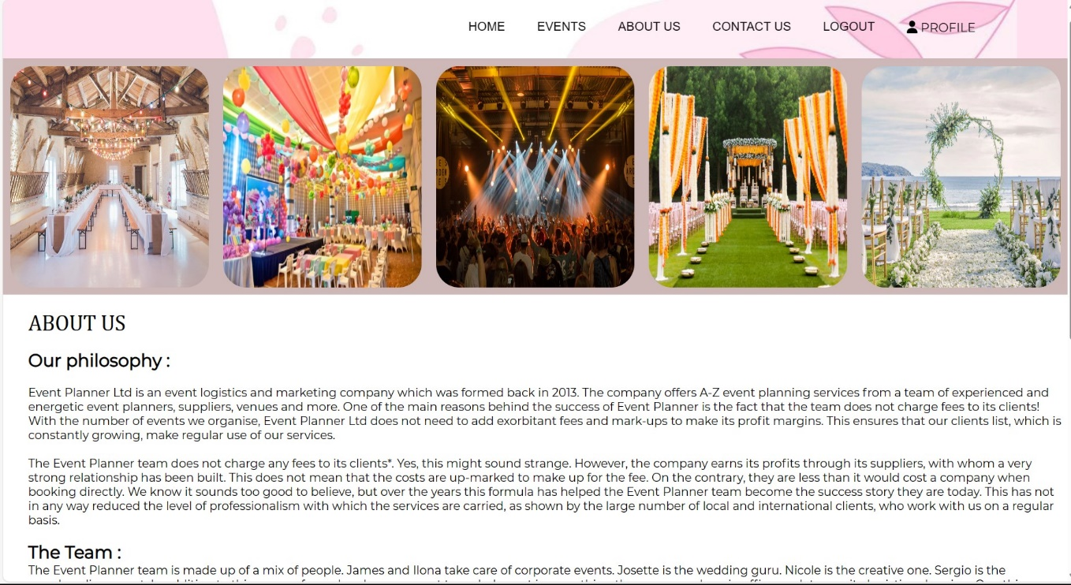

**About Us Page**

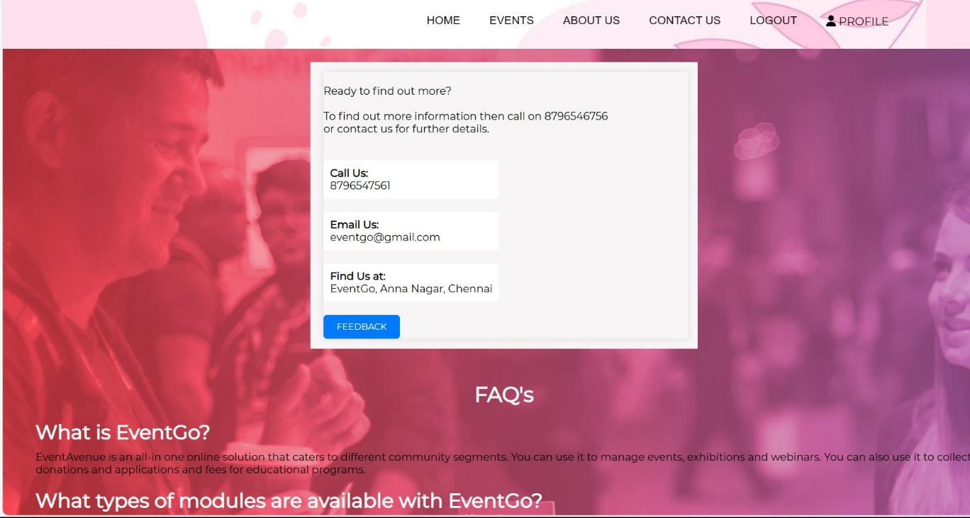

**Contact Us Page**

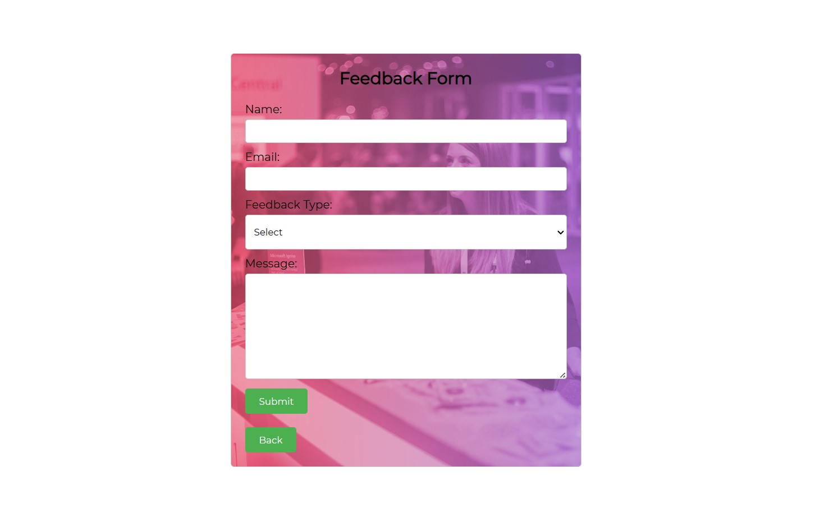

**FeedBack Page**

**Admin Flow Chart:**

Home Page

Login Page

**isLoggedIn?Admin**

Dashboard

Add Events

User Information

Events List

Bookings List

**Admin Modules:**

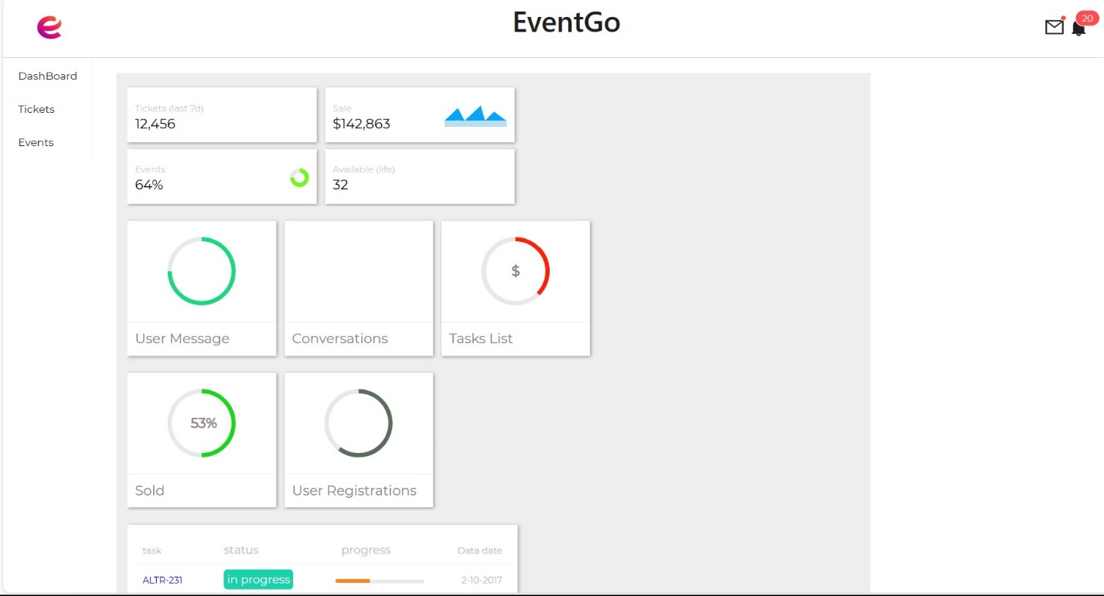

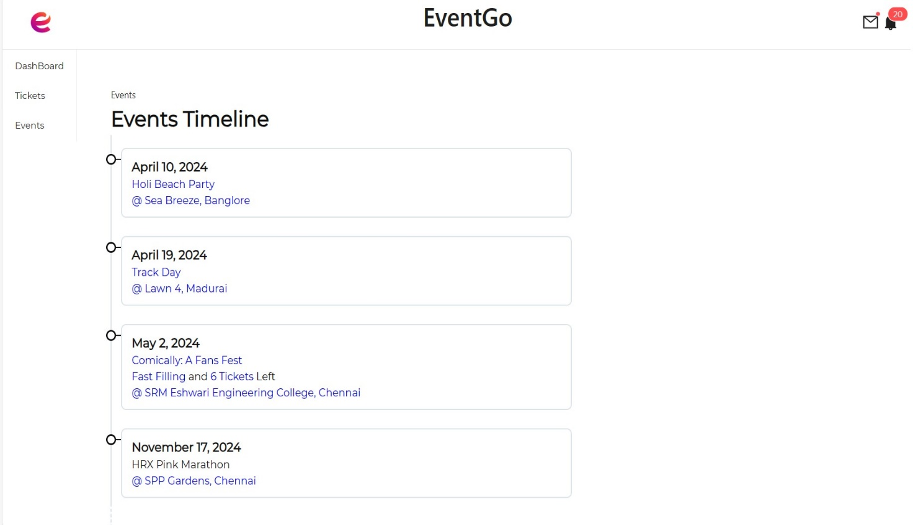**Dashboard**

**Events List**

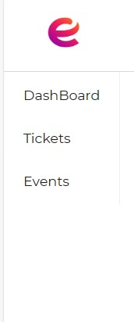

**Admin Side Bar**

**Conclusion:**

In conclusion, Event Craft Pro is your trusted partner in creating unforgettable moments that will be cherished for a lifetime. With our commitment to excellence and attention to detail, we ensure that every event is executed flawlessly, leaving a lasting impression on you and your guests. Whether it's an intimate gathering or a grand celebration, our dedicated team is here to turn your vision into reality. Say goodbye to the stress of event planning and hello to effortless elegance with Event Craft Pro. Let us handle the logistics while you enjoy the magic of your special day. Elevate your celebrations with Event Craft Pro – where dreams become extraordinary realities.